**1.Windows installation**

**Requirements**

* **Processor**: 1GHz or faster
* **RAM:** 1GB for 32-bit OS or 2GB for 64-bit OS
* **Storage:** 16GB for 32-bit OS or 20GB for 64-bit OS
* **Graphics card:** DirectX 9 graphics device with WDDM (Windows Display Driver Model) driver
* **Display:** 800x600 resolution
* **Network:** Internet connection

Installation

**Step 1:** Download and Open Windows 10 installation media from [Microsoft's website](https://www.microsoft.com/en-gb/software-download/windows10).

**Step 2:** Accept license terms by choosing Accept.

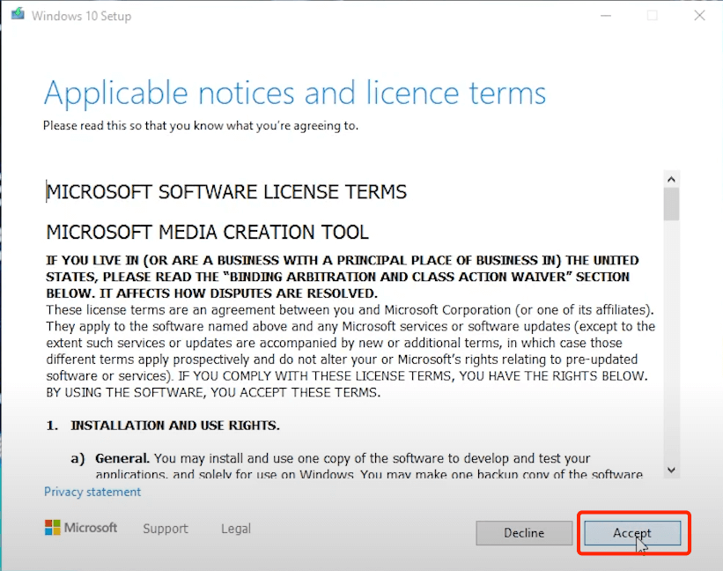

**Step 3:** Choose Create installation media and click Next.

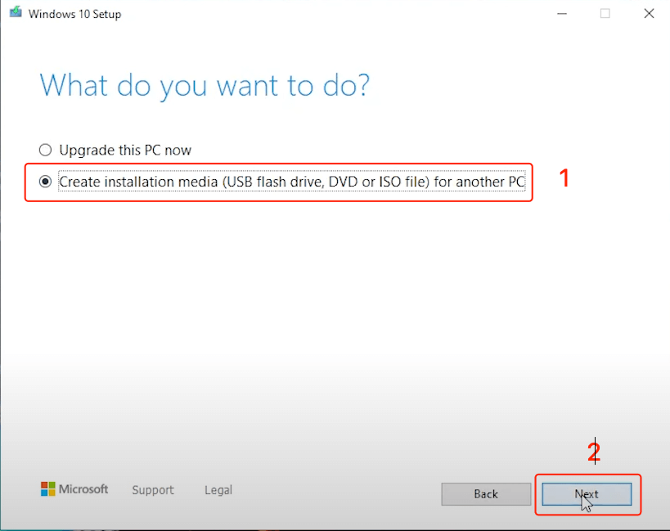

**Step 4:** Click Next.

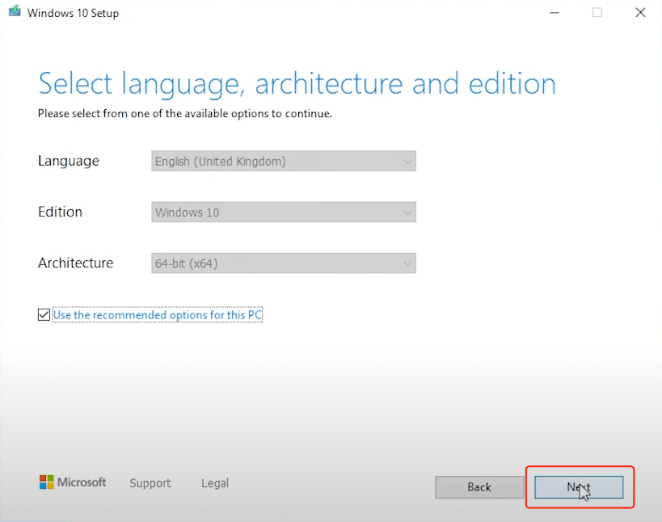

**2. Downloading &installing Visual Studio Code**

1. Open your web browser and navigate to the official Visual Studio Code website at [**https://code.visualstudio.com**](https://code.visualstudio.com/).

2. Click on the “Download for Windows” button. The website will automatically detect your system architecture and suggest the appropriate version (32-bit or 64-bit).

3. Once the download starts, it may take a few moments to complete.

# **Step 2: Installing Visual Studio Code**

1. Locate the downloaded file, usually in your computer’s “Downloads” folder. The file will be named something like `VSCodeSetup’

2. Double-click the downloaded file to start the installation process.

3. The installation wizard will appear. Click “Next” to continue.

4. Review the License Agreement, and if you agree to the terms, select “I accept the agreement” and click “Next.”

5. Choose the installation location. By default, VS Code installs in the `C:\Program Files\Microsoft VS Code` directory. You can change this location if needed, but it’s usually best to stick with the default settings. Click “Next” to proceed.

6. Select the additional tasks you’d like to perform during installation. The options include creating shortcuts on the desktop and adding VS Code to the system PATH for easier command-line access. Make your selections and click “Next.”

7. Choose the Start Menu folder where you want to create shortcuts for VS Code. Click “Install” to begin the installation.

8. The installation process will commence, and you’ll see a progress bar indicating the status.

9. Once the installation is complete, click “Finish” to exit the installer.

# **Step 3: Launching Visual Studio Code**

1. After installation, you can launch Visual Studio Code in several ways:

* **From the Start Menu:** Look for “Visual Studio Code” in your Start Menu and click on it.
* **From the Desktop Shortcut:** If you selected this option during installation, you’ll find a shortcut on your desktop.
* **From the Command Line:** You can open a command prompt or PowerShell window and type `code` to launch VS Code.

2. When you first open VS Code, you’ll be greeted by a welcome screen. From here, you can start configuring the editor to your liking.

# **Step 4: Customizing Visual Studio Code**

Visual Studio Code is highly customizable to suit your development needs. You can install extensions, change themes, and configure settings to make it work just the way you want. Here are a few things you can do to get started:

* **Install Extensions:** Click on the Extensions icon in the sidebar (or press `Ctrl+Shift+X`) to browse and install extensions that add functionality to VS Code.
* **Change the Theme:** Click on the gear icon in the lower left corner to access settings. You can search for “Color Theme” to change the editor’s appearance.
* **Configure Settings:** In the settings, you can tweak various aspects of VS Code, including keybindings, file associations, and more. Explore the settings by clicking the gear icon and selecting “Settings.

3.Gitbash installation

**a) Download Git Bash**:

* + Visit the [official Git downloads page](https://git-scm.com/downloads).
  + Choose the appropriate version for Windows and download it.

**b) Install Git Bash**:

* + Double-click the downloaded file to start the installation.
  + You’ll see the “Select Destination Location” screen. Define the path where you want to install Git Bash, and then click “Next.”

**C) Verify Installation**:

* + Once the installation is complete, open Git Bash by finding the included .exe file.
  + To verify the installation, type git version in the Git Bash terminal.